Kids for Christ
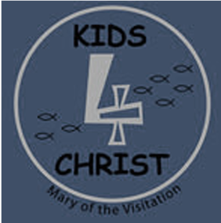

Youth Group Registration

(Big Lake - Grades 3-5)
Student’s Name |  |  | Grade
Street
City, State, ZIP
Parent’s Name |  |  | Email
Home Phone |  |  | Cell Phone
Please list any food allergies
Where does child normally go after school? |  |  | Phone number and contact name if applicable
Which school bus?
In case of emergency contact: |  |  | Phone
Who will be picking child up? (child will be released ONLY to person(s) listed)
Are you able to help after school? (please circle) | YES |  |  |  | NO
If Yes, which months? | Oct | Nov | Jan | Feb | Mar | May

Please Circle the sessions your child will attend:
Oct 12 | Nov 9 | Jan 11 | Feb 8 | Mar 15 | May 17  (end of year BBQ)

Please cut at line above and keep bottom portion for your records
3rd-5th Grade Kids for Christ Youth Group – Held on the following Wednesdays, after school from 2:30pm-4:30pm
Oct 12 | Nov 9 | Jan 11 | Feb 8 | Mar 15 | May 17  (end of year BBQ)
Children will meet at Independence Elementary School at the main entrance immediately after school.
They will walk over to MOV Youth House with Adult Chaperones.
All children MUST be picked up at Youth House by 4:45pm

If your child is registered, but unable to attend the session as planned, please notify Amber Wilfahrt NO LATER than 9am on the day of the session at 507-220-1305 and aelindmeier@gmail.com

